Medway Mindfulness

Mindful by Nature

When: Sunday October 10th, 17th, 24th, from 4.00-5.30 p.m.

Where: Meeting at Pilgrims Way, Detling (see map below).

What: This course will build on the core skills of mindfulness and also include practices from forest bathing. Each week will start with a guided group meditation and mindfulness practice. There will then be a short session where we will prepare for the practices for the day. The practices will be both as a group and on an individual basis.

Week 1. Invitations in the Forest. We have been conditioned to think of the world outside as an object outside of us. However, forest bathing assumes there is an open invitation to a more reciprocal relationship between humans and the natural world. This session will aim to develop this idea in our own thinking and practice. We will explore Earth Invitations, Air Invitations, and Fire Invitations.

Week 2. Coming to our Senses. This week will focus on Proprioception and Interoception, Imaginal sensing, Mirror sensing and Heart sense. All of these terms refer to ways we sense our own bodies and our bodies in movement, as well as the movement, sound, and life all around us.

Week 3 The Power of Trees. This will aim to develop a much deeper sensory and imaginative relationship with trees and more especially a particular tree that you will choose.

Please complete this section.

Title First Name Surname

Address

Phone No (day, evening, mob) E-mail

What are your hopes in doing this course?

Do you have any concerns in doing this course?

Will you be able to get to the location or would you like to request help with transport?

Please detail any mobility or other requirements that would need to be taken into consideration in doing a course that is outside and sometimes possibly on steep and/or uneven ground.

The cost of this course is £25:
□ I enclose a cheque for £ □ I have made a transfer for £

Online details: Barclays Bank; account name:
Medway Mindfulness, sort code: 20-45-45 Account no. 50093491 reference: ‘your name’.

DATA PROTECTION
Before and during the course I may need to contact. If you consent how would you like me to contact you?

PHONE
EMAIL
BOTH OF THE ABOVE
Do you also consent to me contacting you after the course with other details of courses/events that Medway Mindfulness is offering?

Please tick for Yes

Signature Date

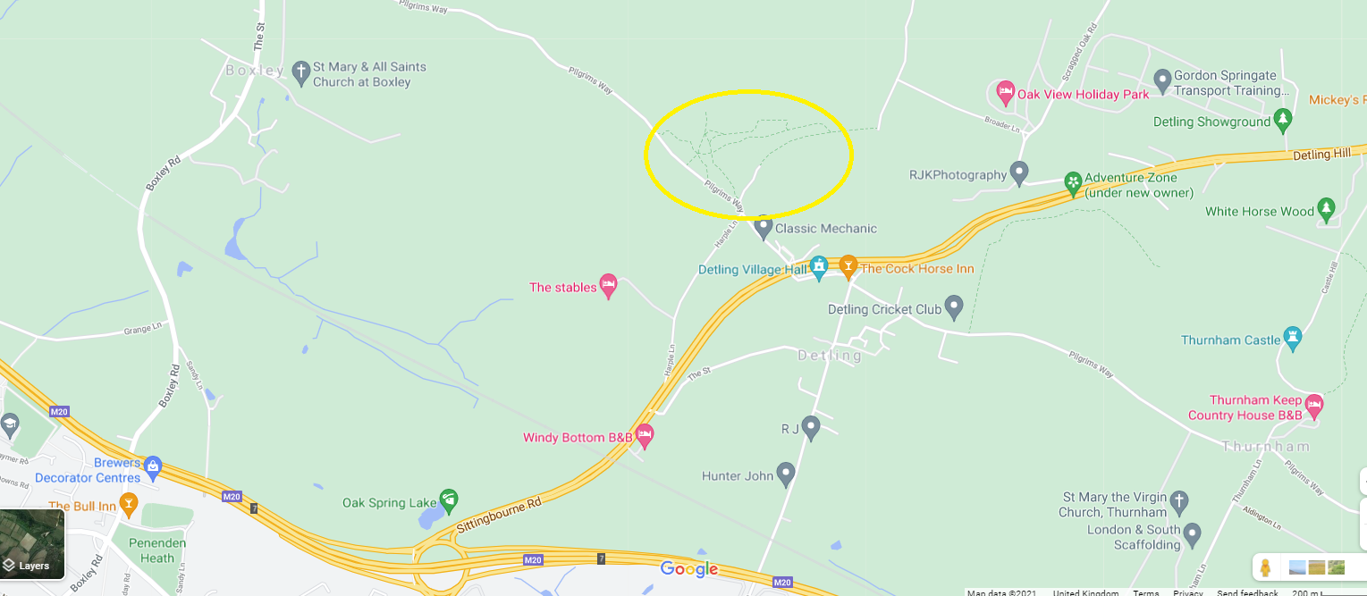

The course will take place in the area marked with a yellow circle.

